PRACTICAL 2: ETHERNET CABLE CONSTRUCTION
Objective
Construct and test Ethernet patch cables using T568B.
Activities
1. Measure and cut cable.
2. Strip cable jacket.
3. Arrange conductors according to T568B.
4. Crimp RJ45 connectors.
5. Test completed cables.
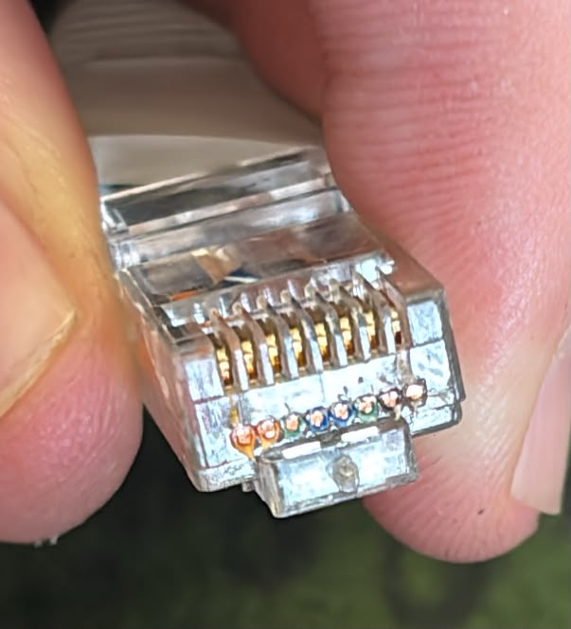
T568B Wiring Standard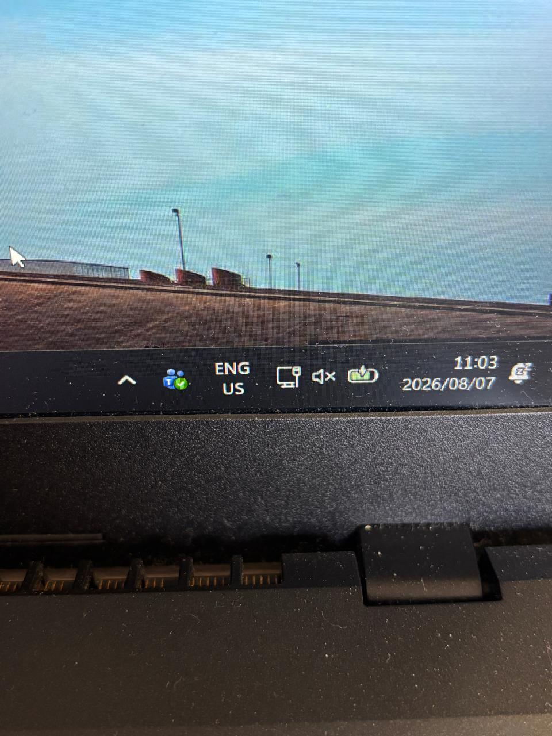
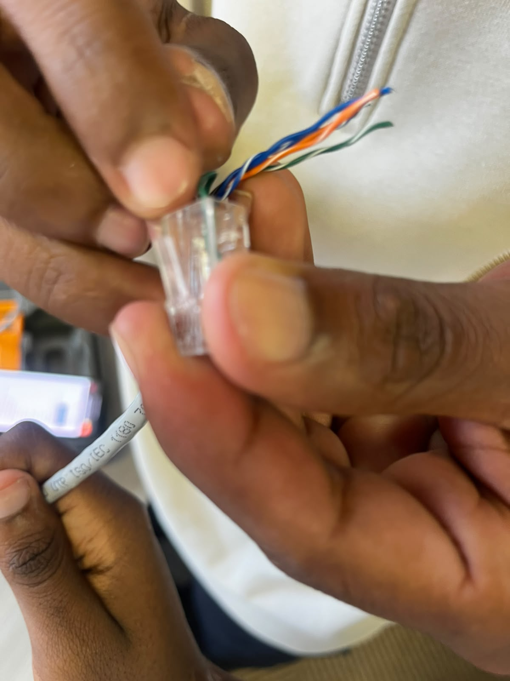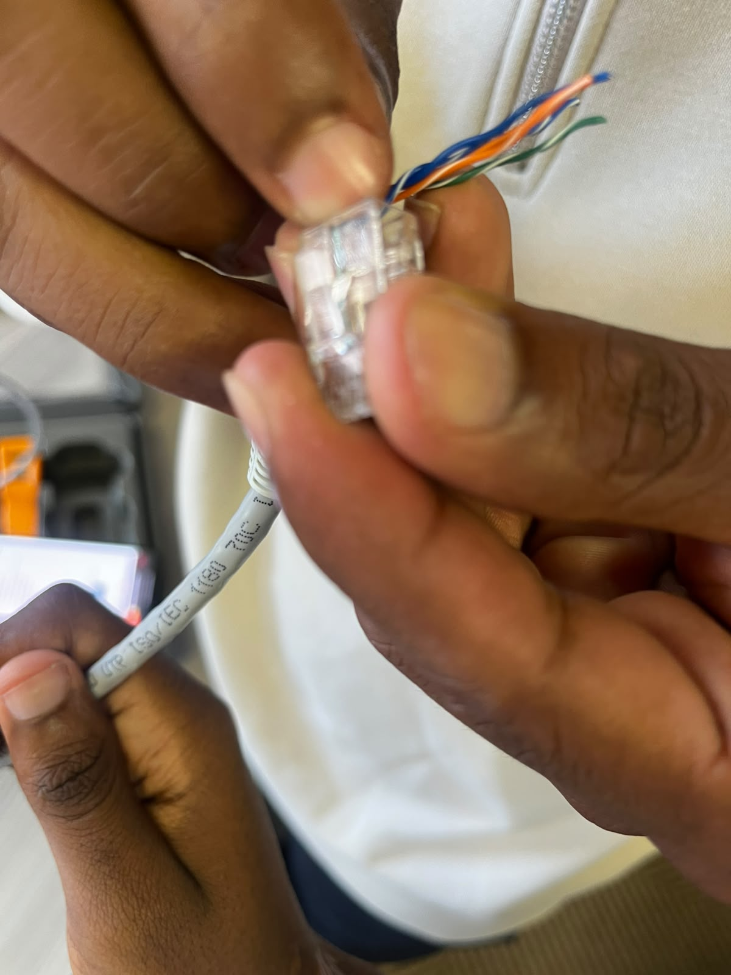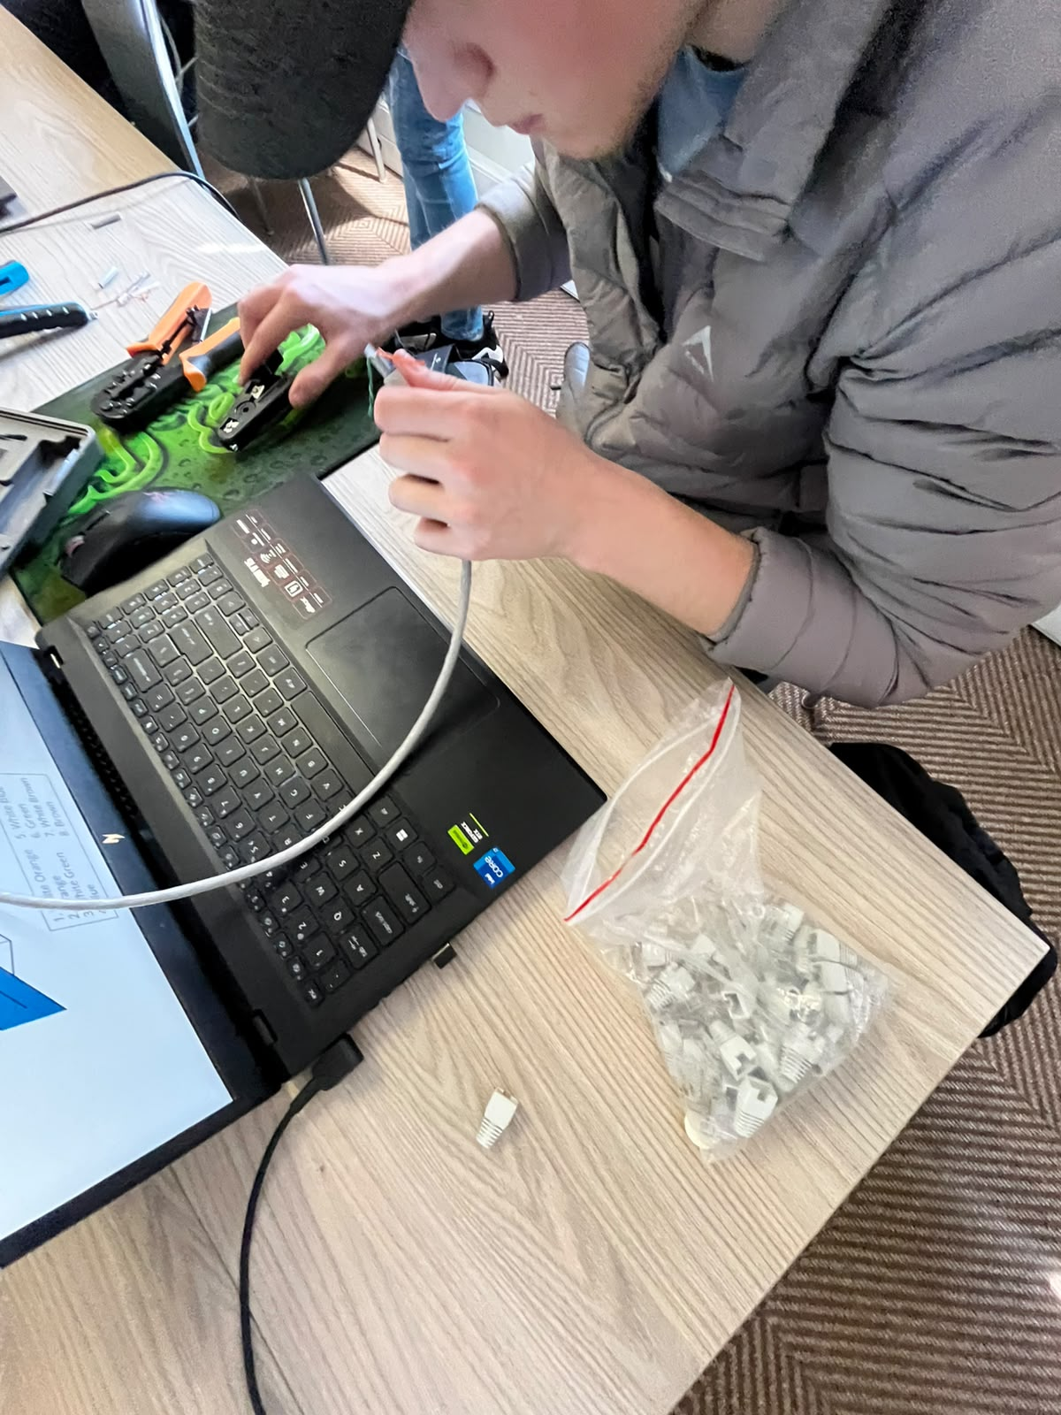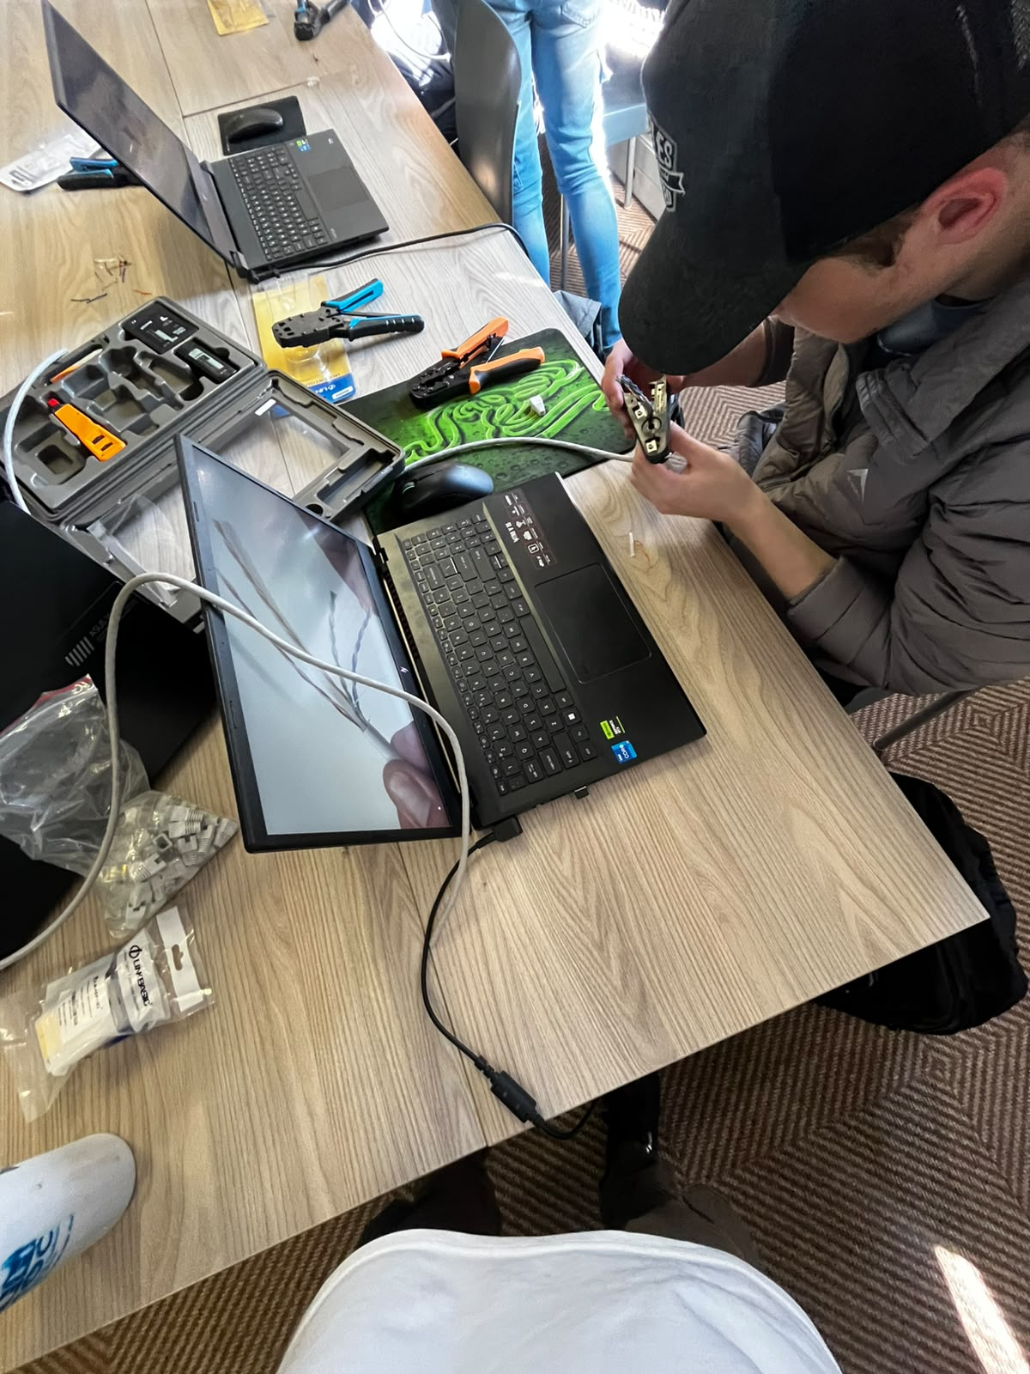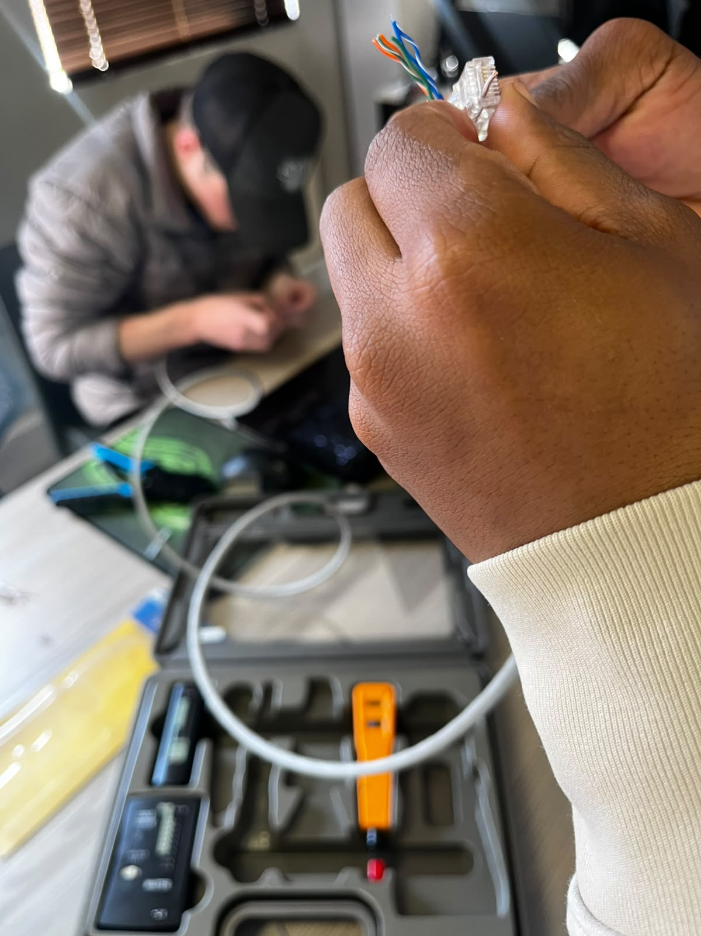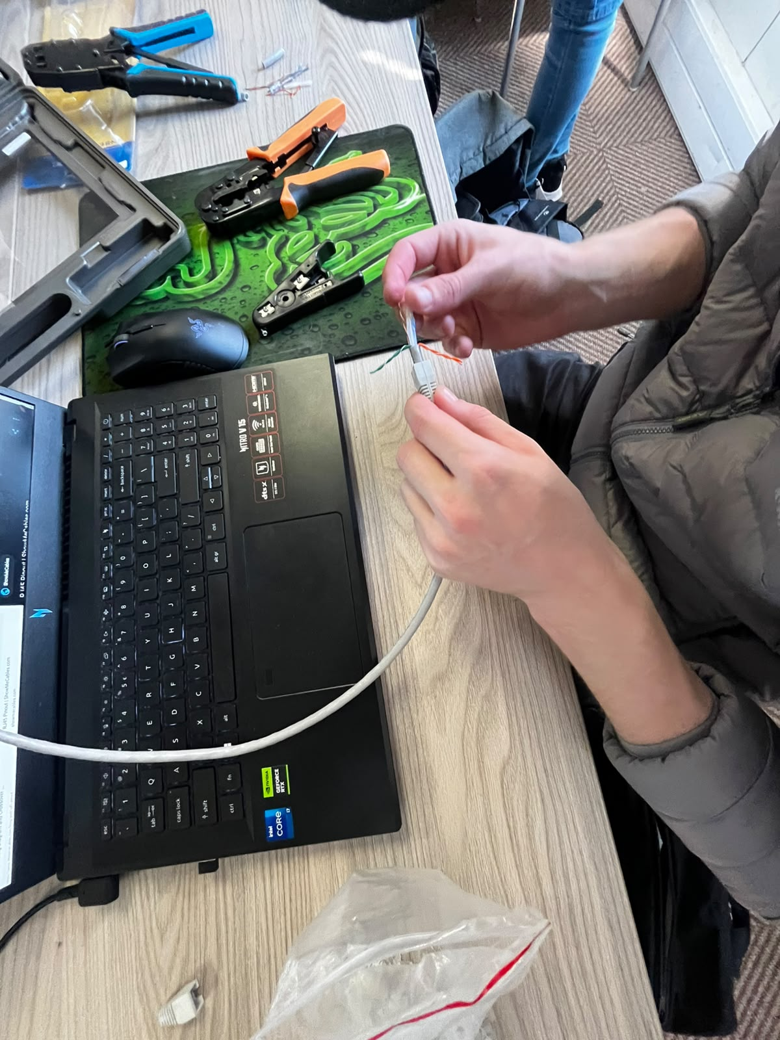
1. White/Orange
2. Orange
3. White/Green
4. Blue
5. White/Blue
6. Green
7. White/Brown
8. Brown
Deliverable
Three tested Ethernet cables.
Assessment Rubric (10 Marks)
Criteria Marks
Correct cable sequence 4
Cable preparation 2
Crimp quality 2
Connectivity testing 2
Total 10

